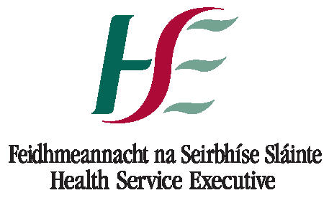


School of Nursing, Health Sciences and Disability Studies
Master of Health Sciences/Postgraduate Diploma (Nursing/Professional Studies)
(90 ECTS)
2nd and Subsequent Standalone Module

Please complete using black ink and BLOCK CAPITALS. Please also note there is an application processing fee of €20
with your application form payable via the following link: www.stangelaspayments.com

Name of Module(s): _______________________________________________________________

Surname Forenames
Maiden Name Nationality
Country of Birth : Date of Birth
County of Birth Gender
PPS Number Mobile Number
Main Telephone No: Work Number:
Email :
Correspondence Address (Please include Eircode)
………………………………………………………………………………………………………………………………………………………………..
St Angela’s College makes every effort to facilitate students with disabilities or special needs (physical/sensory/learning or mental health). You may choose to indicate any disability, health condition or specific learning difficulty in this part of the application form. This information is requested in order to ensure that any support needs are identified. The information does not form part of the selection process.

Current Student: Yes / No- if yes student number:
Previous student of St. Angela’s College: Yes / No – if yes student number:

Registration with Nursing and Midwifery board of Ireland
NMBI PIN :(current registration required):

Original Date of Registration:
Please tick whether you are:
RGN RPN RCN RM RPHN RNID Other please specify

Stand Alone Modules Completed

Name of Module | Commencement Date | Completion Date

Present Work Location
Employer
Address in full
Telephone No.
Job Title
Hours worked per month
Outline duties

Funding Please tick as applicable:

 | I am applying for funding. |  | I am funding myself.
All students should apply for funding from the Centre of Nursing and Midwifery Education of their local Health Service Executive area.

I acknowledge that the particulars given in relation to this application are in all respects true.

SIGNATURE DATE

Checklist
Before submitting this application, please ensure that you have satisfied the requirements listed below. Incomplete applications will not be considered.

1 Fully competed application form
- Application Fee €20 (non-refundable) – STRICTLY NO CASH – payable to St Angela's College at WWW.STANGELASPAYMENTS.COM
- Copy of your current Nursing and Midwifery Board of Ireland registration

Application forms and relevant accompanying documents should be returned to:

Postgraduate Administrator
School of Nursing, Health Sciences and Disability Studies
St Angela’s College, Lough Gill
Sligo

or sent by email to:
nhsds@stangelas.ie

